Assignment Writeup
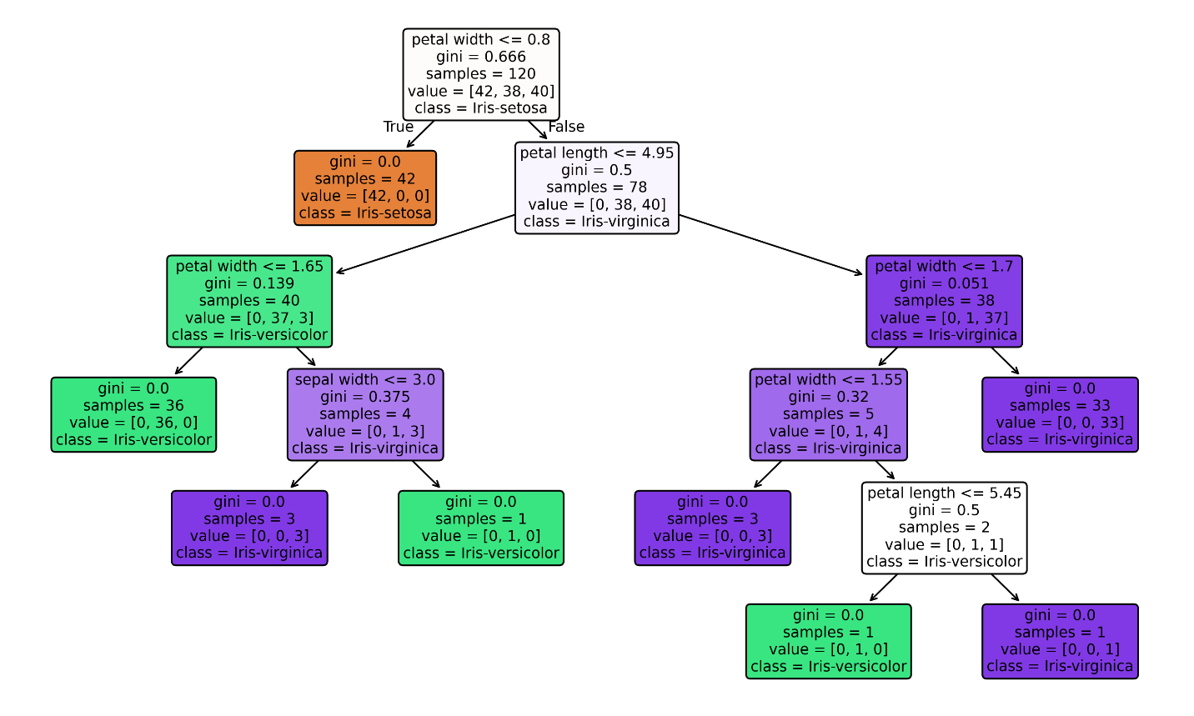
The root decision for the tree structure starts with dividing the flowers whom are < or = to .8 in width. This completely isolates all the Iris-setosa making it an efficient split. There are 2 other key splits which almost completely distinguished versicolor from virginica. The first is the petal length < or = 4.95, this being false partitioned most of the virginica together(having only 1 outliar), same with the versicolor when that condition held true(3 outliars). The second is the petal width being < or = 1.65, which separated the 3 virginica outliars with similar petal length to the versicolors. Also the sepal width seemed to be the least useful feature in distinguishing the iris classes since it was only used once for a minor branch. Lastly, The tree reaches a depth of 5 and displays 15 nodes total, with 8 being leaf nodes.

